**Intensity Level Slicing**

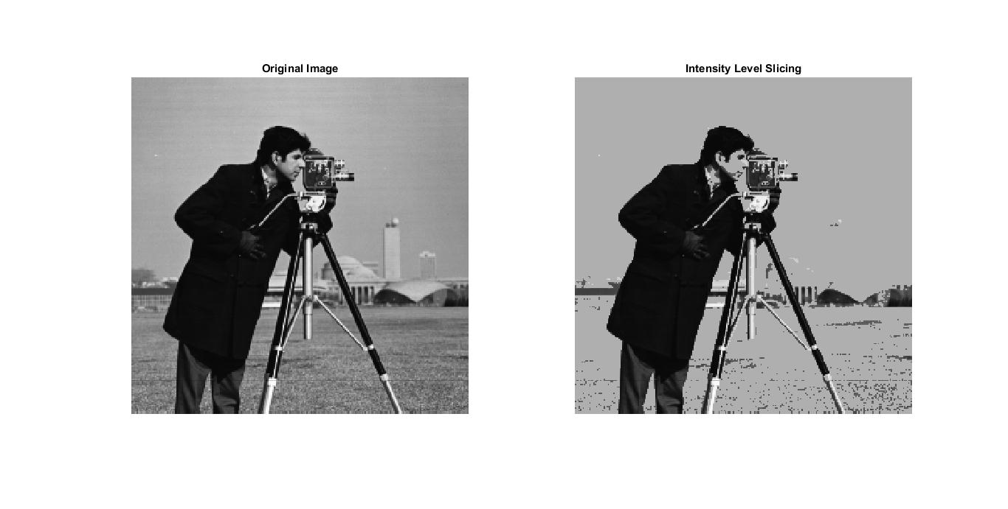

* Image is transformed by transformation function as shown in the graph above(x denotes a and y denotes b here):

b=a if a<=100 and a>200

b=175 if a>100 and a <=200

where

a is every pixel of original image

b is pixel of output image

* We observed that grey colours are submerged into one colour intensity 175 like we cannot see the buildings behind cameraman.